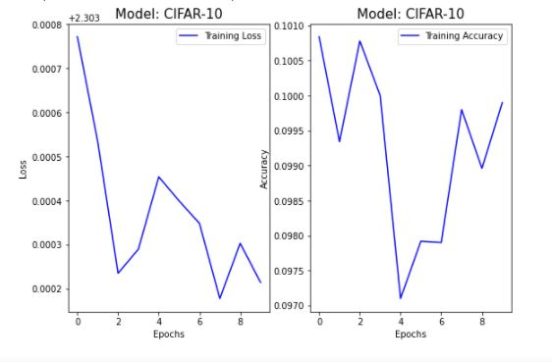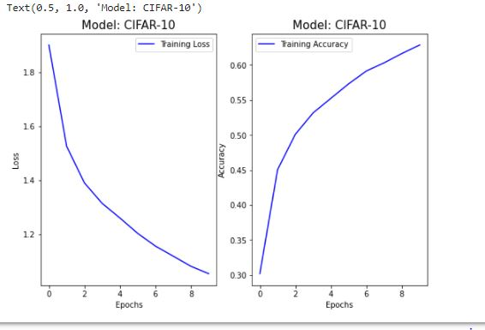Question2 part 3

Figure2 LeNet CNN using Adam optimizer

Figure 1 LeNet CNN using SGD optimizer

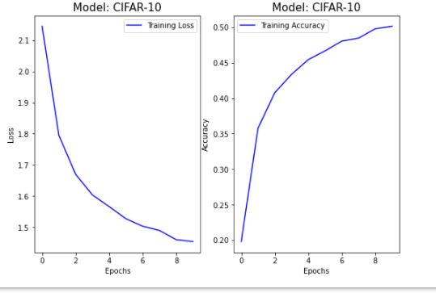

Figure 3 LeNet CNN using RMS Prop optimizer